1. Create a DynamoDB table with partition key as ID.

2. Add 5 items to the DynamoDB table.

3. Take backup and delete the table.

1. Create a DynamoDB table with partition key as ID.

DynamoDB > create table >

* Table name ( student ) > Partition key( name) > Sort key – optional(role number) >Table settings (Customize settings)
* Table class > Choose table class > DynamoDB Standard
* Read/write capacity settings > On-demand

**Secondary indexes**

* Create local index ( in local index Partition key will be same as basic)
* New local secondary index >Sort key(date of birth) > create
* Create global index ( in global index Partition key will be different )
* New global secondary index > Partition key (fav-sports) > Sort key (fav-subject)
* Create table

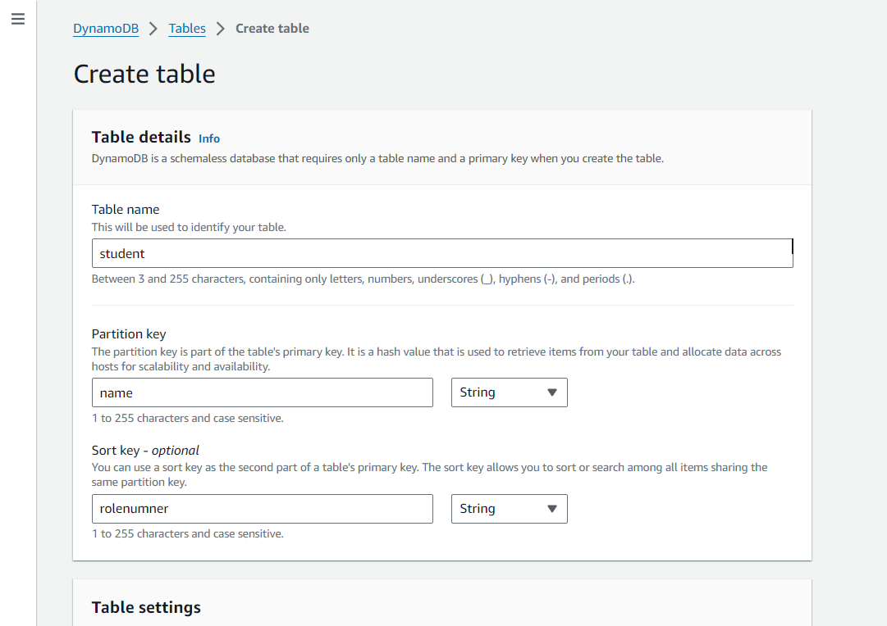

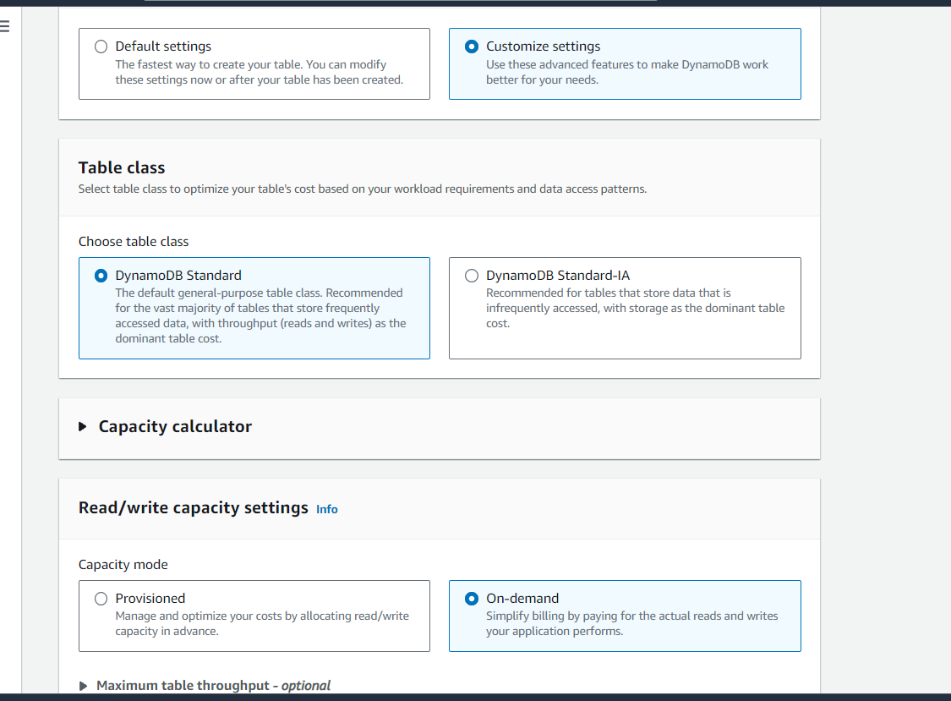

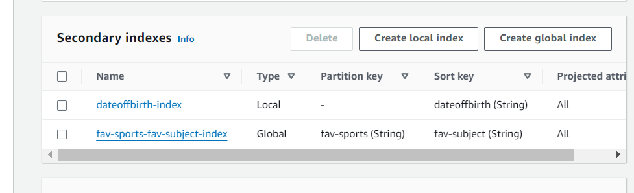

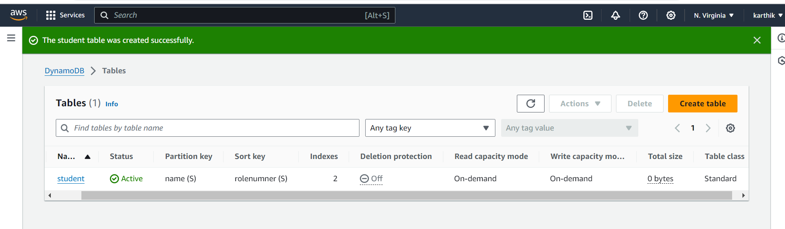

2. Add 5 items to the DynamoDB table.

* Go to table > Explore item > create item
* Create 5 items as shown in below table

|  |  |  |  |  |
| --- | --- | --- | --- | --- |
| **NAME** | **ROLL NO** | **DOB** | **FAV-SUB** | **FAV-SPORTS** |
| KARTHIK | RL111 | 1992 | AWS | CRICKET |
| KISHOR | RL222 | 1993 | GPON | FOOTBALL |
| KRISHNA | RL333 | 2000 | NETWORKING | CRICKET |
| KUMAR | RL444 | 1992 | MATHS | FOOTBALL |
| KARTHIK | RL555 | 2002 | DATABASE | BASEBALL |

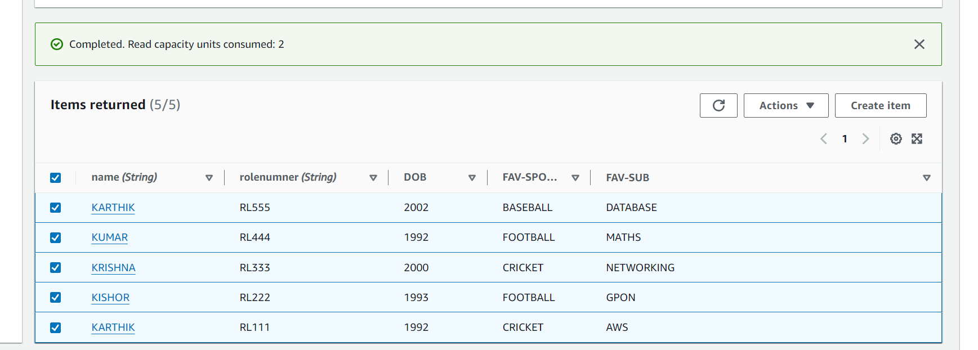

3. Take backup and delete the table.

* GO TO backup > create back up > **Create on-demand backup >** Source table (student )
* Backup management (Backup with AWS Backup) > Backup window (Create backup now)
* Rest keep default and create backup
* To check the backup > go to back up > view backup job details

Backup created

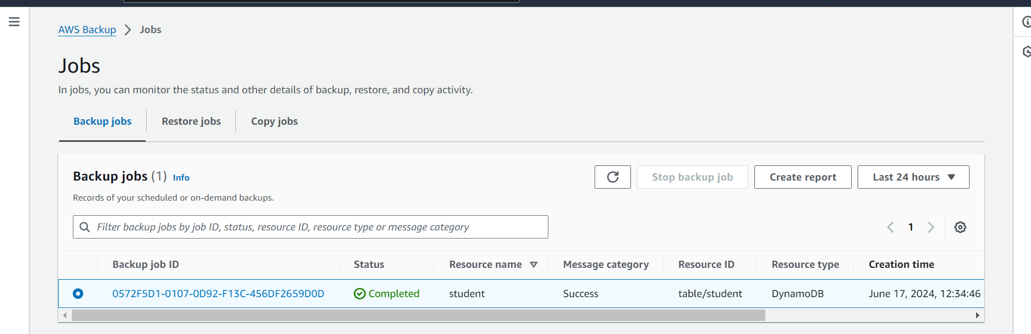

Backup deleted

